Project Planning
- Project Overview
The Restaurant Survey App is a cross-platform mobile application built with Flutter that allows restaurant customers to explore meals, submit ratings, write comments, and even record voice reviews.
The app also provides an Admin Dashboard to help restaurant managers analyze meal performance, ingredient feedback, and overall customer satisfaction.
This system bridges the gap between customers and restaurants by collecting structured, meaningful data, enabling continuous quality improvement.
- Project Objectives
- Provide users with a simple, bilingual interface to review meals (English ↔ Arabic).
- Enable restaurants to collect quantitative (ratings) and qualitative (comments, voice) feedback.
- Support smart validation between ratings and comments to detect inconsistencies.
- Offer an admin dashboard with filtering, sorting, and ingredient-level insights.
- Store and manage all data efficiently using a normalized, scalable database.
- Project Scope
- Development of a User Mobile App for browsing meals, submitting ratings, and writing or recording feedback.
- Implementation of an Admin Dashboard App to view aggregated ratings, comments, and ingredient-level analysis.
- Voice feedback option allowing users to record short reviews.
- Bilingual support (English & Arabic) for broader accessibility.
- Database integration with Supabase for authentication, data storage, and synchronization.
- Smart validation to ensure consistency between ratings and comments.
- Project Components
Component | Description
User App | Allow customers to browse meals, rate them, and leave comments or voice feedback.
Admin App | Provides dashboards with ratings, total reviews, and per-ingredient analysis.
Database | Stores meals, ingredients, users, and reviews using normalized relations.
Backend | Supabase (or Firebase) manages authentication, real-time sync, and database APIs.
- Tools and Technologies
Category | Tool/Technology
Frontend | Flutter (Dart)
Backend | Supabase
Design | Figma
Version Control | GitHub
IDE | Android Studio
Documentation | Microsoft Word

- Team Roles
Role | Member | Responsibilities
Project Lead | Mohamed Wael Mohamed Safwat | Database design, Flutter implementation, testing
Developer | Abdelrahman Amr Abouzeid | Database design, Flutter implementation, testing
UI/UX Designer | Muhammed El-Hussein Taha  Omar Mohamed Hassan | Design wireframes and ensure usability, Flutter implementation, testing
Documentation Specialist / Developer | Omar Magdy | Prepare the final report and visuals, Flutter Implementation, testing

- Expected Outcome
- A functional Flutter app for customers and admins.
- Accurate, relational database with many-to-many links between meals, ingredients, and reviews.
- A bilingual, user-friendly UI/UX.
- Insightful dashboards for restaurant performance.
- Full documentation (planning, stakeholder analysis, database design, UI/UX).
Stakeholder Analysis
- Overview
Stakeholder analysis identifies all individuals and groups who have an interest in or influence over the project. Understanding their needs, expectations, and level of involvement helps ensure the project is successfully designed, developed, and deployed.
- Table
Stakeholder | Role / Description | Interest in the Project | Level of Influence | Expectations / Responsibilities
End Users (Customers) | Individuals who browse meals, view ingredients, and submit reviews. | High | High | Expect an easy-to-use, fast, and reliable app to explore meals and share opinions.
Restaurant Owners / Admins | Manage meals, ingredients, and monitor user reviews. | High | High | Need accurate data management and an admin dashboard to monitor app content.
Developers | Responsible for coding, testing, and deploying the system. | High | Medium | Expect clear requirements and a database structure for efficient development.
UI/UX Designers | Design the app’s interface and ensure a smooth user experience. | Medium | Medium | Need user feedback and functional requirements to guide the design.
Project Manager / Team Leader | Oversees the project timeline and deliverables, ensuring coordination among team members. | High | High | Ensures the project stays on schedule, meets scope, and aligns with stakeholder needs.
Database Administrator (DBA) | Designs and maintains the database schema and relationships. | Medium | Medium | Ensures data consistency, normalization, and efficient performance.
DEPI Program / Instructor (Evaluator) | Reviews the project as part of an academic or training assessment. | Medium | High | Expects professional documentation, clean architecture, and functional implementation.

- Influence vs Interest
Influence | Low Interest | High Interest
High Influence | Instructor / Evaluator | Restaurant Owners, Project Manager
Low Influence | UI/UX Designers | End Users, Developers

- Summary
Effective communication and collaboration between all stakeholders ensure the success of the Restaurant Review App. The project’s focus is on balancing user satisfaction, administrative control, and technical feasibility within the defined scope.

Database Design
- Overview
The database design aims to ensure efficient data organization and retrieval for both the User App and Admin App.
It follows a relational model with normalized tables to reduce redundancy and maintain consistency between meals, ingredients, reviews, and users.
- Entity-Relationship (ER) Model
The system is built around four main entities and several relationship tables connect them.
Entity | Attributes | Description
Users | user_id (PK), phone, name, password, created_at | Stores user details.
Meals | meal_id (PK), meal_name, meal_image, description | Represents each meal available for review.
Ingredients | ingredient_id (PK), ingredient_name, ingredient_image | Stores meal ingredients.
Reviews | review_id (PK), rating , comment, voice_review_url, created_at, user_id (FK), meal_id (FK) | Contains user feedback, including text and voice reviews.
- Relationship Tables
Table Name | Attributes | Relationship Type | Description
Meal_Ingredients | meal_id (FK), ingredient_id (FK) | Many-to-Many (Meals, Ingredients) | Defines which ingredients belong to each meal.
Ingredient_Reviews | ingredient_id (FK), review_id (FK), ingredient_rating | Many-to-Many (Ingredients, Reviews) | Stores the user’s perception of specific ingredients within a review.
- Schema Diagram
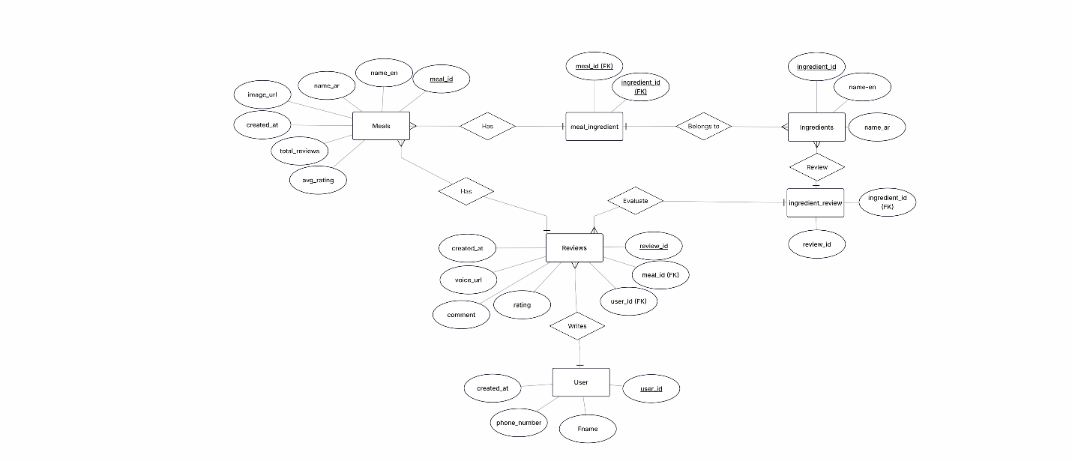
The following Entity–Relationship Diagram (ERD) illustrates the structure of the database and the relationships among all entities used in the Restaurant Survey App.

UI/UX Design
- Overview
The UI/UX design aims to create an intuitive, visually appealing, and bilingual experience for both users and administrators. The goal is to make meal browsing, reviewing, and management easy, accessible, and enjoyable for all stakeholders. The design adheres to Material Design principles and utilizes Flutter’s cross-platform components to ensure visual consistency.
- Design Goals
Goal | Description
Simplicity | Keep navigation clear with minimal screens and straightforward actions.
Accessibility | Support both Arabic and English languages (RTL & LTR layout support).
Usability | Provide a smooth user flow for adding reviews and switching between pages.
Consistency | Use unified color themes, fonts, and iconography throughout the app.
Responsiveness | Ensure optimal layout across different devices and screen sizes.

- User App Interface
  - Meal List Page
This is the main browsing screen for users. It displays all meals with their images, names, and short descriptions. Users can scroll through the list and tap on any meal to open its details.
Key UI elements:
- Vertical scroll list
- Meal card with:
  - Thumbnail image
  - Meal title
  - Short Description
- Clean spacing and rounded containers
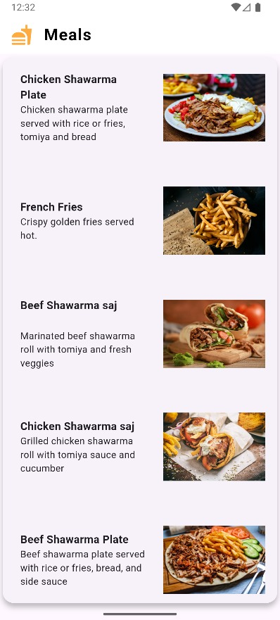
Mockup:

  - Meal Details & Survey Page
When a user selects a meal, they are taken to the detailed screen designed to collect structured feedback.
Features:
- Large meal image at the top
- Survey Section containing:
  - Service rating (1–5 stars)
  - Food Quality rating (1-5 stars)
  - Overall Experience rating
  - Comment box with voice recording option
  - Recommendation dropdown
- “Submit” button with visual emphasis
- Real-time validation to detect inconsistent reviews
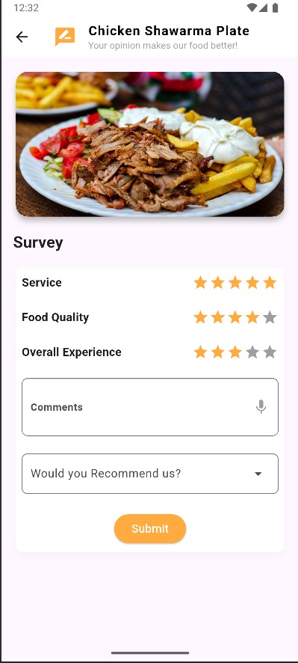
Mockup:

  - Language Toggle
- Button in the app bar or settings to switch between English and Arabic instantly.
- Automatically mirrors layout for RTL support when Arabic is selected.

- Admin App Interface
  - Dashboard Page
- Display all meals with:
  - Image Thumbnails
  - Average rating
  - Total number of reviews
- Includes sorting and filtering tools
  - Meal Analysis Page
- Shows:
  - Overall meal rating
  - User comments and linked voice reviews.
- Designed for data visibility and easy review management.
- Color Palette & Typography
The app uses fresh, warm, food-friendly colors aligned with appetizing UI trends.
Element | Style
Primary | #FF7043 (Deep Orange)
Secondary | #FFC107 (Amber)
Buttons | Orange gradient
Background | #FFFFFF (White)
Text | #212121 (dark grey)
English Font | Roboto
Arabic Font | Cairo (supports RTL beautifully)

- Interactive Elements & UX Features
- Star Ratings: Easy-to-use tap-based system.
- Voice Reviews: Users can record audio instead of typing.
- Dropdown Recommendations: For structured survey responses
- Animated Transitions: Smooth page navigation and card animations.
- RTL Support: Full mirroring for Arabic UI.
- Tools & Frameworks Used
  - Flutter
  - Figma for UI Mockups
  - GetX/Provider for State Management
  - Google Fonts for multi-language typography
- Summary
The UI/UX design focuses on delivering:
- A smooth experience for customers submitting meal reviews
- A powerful analytical interface for administrators
- A modern, bilingual, and visually consistent design
- Accessible interactions such as voice input, intuitive ratings, and RTL support

